School of Computing Science and Engineering

LAB - 5 Exercises

Problem- 1:

Write a Naïve Bayes Classifier in python without using any package for the following dataset

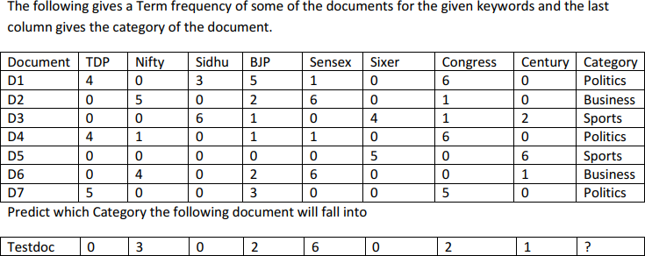

Challenging Exercise-1:

Take any large text corpora, do the necessary preprocessing and built a Naïve Bayes Classifier and draw the inferences.